Nictitans Gland Prolapse (Cherry Eye)
Animals have an extra eyelid, called the third eyelid, which is present in the inner corner of the eye appearing either pink or pigmented in color. There is a gland deep within the third eyelid that produces about one third of the tears in dogs. In some instances, the third eyelid gland can prolapse outward which causes it to become irritated, swollen and red. This condition is also called a “cherry eye” because of its appearance.

The clinical sign of cherry eye is a large, red mass protruding from the inner corner of the eye. It can sometimes come and go, and both eyes can be affected. Several dog breeds have a higher predisposition for this condition, including Boston Terriers, Bulldogs and American Cocker Spaniels. The cherry eye most often develops during the first months of life, but less commonly may also occur at later ages.
Diagnosis is made through a complete ophthalmic examination in which the gland’s function to produce tears is also evaluated. The recommended treatment of cherry eye is surgical replacement of the gland to its normal position.
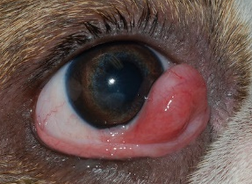
Following surgery, your pet must wear a protective E-collar for about 2-3 weeks or until the surgical site is healed. Occasionally, a cherry eye may recur after surgery. This is common in English Bulldogs and giant breeds, such as Mastiffs. If there is a recurrence, a second surgery is indicated which typically will combine the original technique with a second procedure to optimize the success chance.
Removal of the gland is not recommended because the gland contributes to the tear production that is very important for the overall health of the eye. If the gland is removed, this may place your pet at greater risk of a tear deficiency which can require lifelong medications. However, replacement of the gland does not guarantee that your per will not develop tear deficiency in the future. If surgery is not performed and the gland is prolapsed for an extended period of time, it is more likely to have decreased tear production and also cause chronic eye irritation and discharge.

